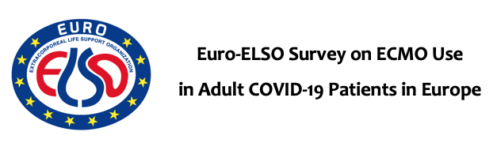

- Center: (ex: Maastricht University Medical Centre) ICU Beds:
- ID Patient (1,2,3….): - Age: - Weight: - BMI:
- Comorbidities: ☐ COPD ☐ Diabetes ☐ Cardiovascular disease ☐ Renal insufficiency ☐ Hypertension
- Sex: ☐ Male ☐ Female
- Race: ☐ White ☐ Asian ☐ Black ☐ Hispanic ☐ Other
- Oro-tracheal Intubation: ☐ Yes ☐ No - Date of Oro-Tracheal Intubation (dd/mm/yyy):
- Oro-Tracheal Intubation Time (days):
- Medical Therapy: ☐ Antibiotics ☐ Antiviral Drugs ☐ Inotropes ☐ Vasopressors
- Prone Therapy: ☐ Yes ☐ No - Date of Prone Therapy Start (dd/mm/yyyy):
- ECMO: ☐ V-V ☐ V-A ☐ V-VA - Date of ECMO Implantation (dd/mm/yyyy):
- Accesses: ☐ Femo-femoral ☐ Jugular (double-lumen cannula) ☐ Femo-Jugular ☐ Jugular-Femoral ☐ Femoral-Axillary ☐ Central
☐ Pulmonary artery - Distal leg perfusion ☐ Yes ☐ No - LV Vent: ☐ Yes ☐ No. (Type……………………………………….)
- Indication for ECMO Implantation: ☐ ARDS ☐ Pneumonia ☐Septic Shock ☐ Myocarditis/cardiac dysfunction ☐ Isolated ventricular failure
- Adjunctive therapies: ☐ CRRT ☐ Plasmapheresis ☐ Cytosorber ☐ Leukopheresis ☐ MARS
- ECMO Configuration Change: ☐ Yes ☐ No - Date of ECMO Configuration Change (dd/mm/yyyy)
- New ECMO Configuration: ☐ V-A ☐ V-V ☐ V-VA ☐ VV-A ☐ Other (specify………………………………….)
- Indication for ECMO Configuration change: ☐ Left Ventricular Failure ☐ Right Ventricular Failure ☐ Biventricular Failure ☐ Refractory Hypoxemia ☐ Cannulation site bleeding ☐ Leg ischemia
- Anticoagulation: ☐ Heparin ☐ Bivalirudin ☐ Argatroban ☐ No anticoagulation - Max ECMO Pump flow (L/min):
- Complications on ECMO: ☐ Renal Failure (dialysis) ☐ Neurological complications (stroke/hemorrhage) ☐ G-I Complications (ischemia/bleeding) ☐ Lung complication (pneumothorax, bleeding, emboli)
- Weaning: ☐ Yes ☐ No - Date of Weaning (dd/mm/yyyy):
- Dead on ECMO: ☐ Yes ☐ No - Date of Death on ECMO (dd/mm/yyyy):
- Cause of Death: ☐ Multi-Organ Failure ☐ Cardiac Arrest ☐ Neurological Injury ☐ Septic Shock
- ICU Stay (days):
- Hospital Stay (days):
- Survival to hospital discharge: ☐ Yes ☐ No

